**Assignment-9**

1. What are the different margin options and how do we adjust the margins of the Excel worksheet?

The different Margin Options in Excel are Normal. Wide, narrow and custom margins.

To Adjust Margins we need to Go to Page Layout tab then Click Margins and Choose from options or click Custom Margins

2. Set a background for your table created.

* To set a background image we need to go to Page Layout tab then Click on Background. Select and insert an image (Note: background is only visible on-screen, not in print)

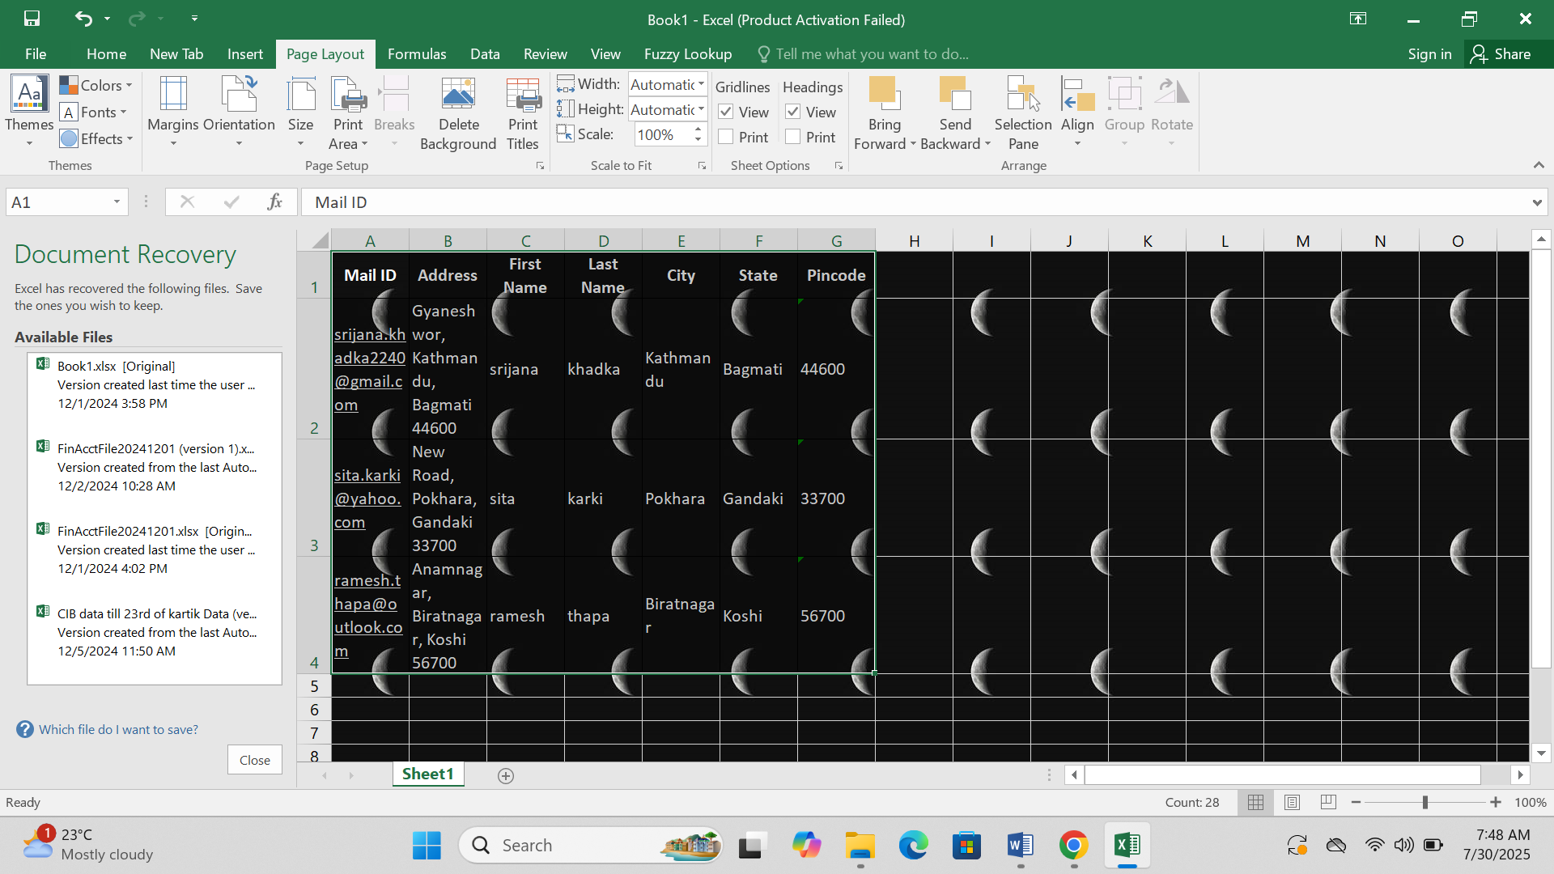

To set background color:

Select the table

Go to Home tab > Fill Color icon > Choose color

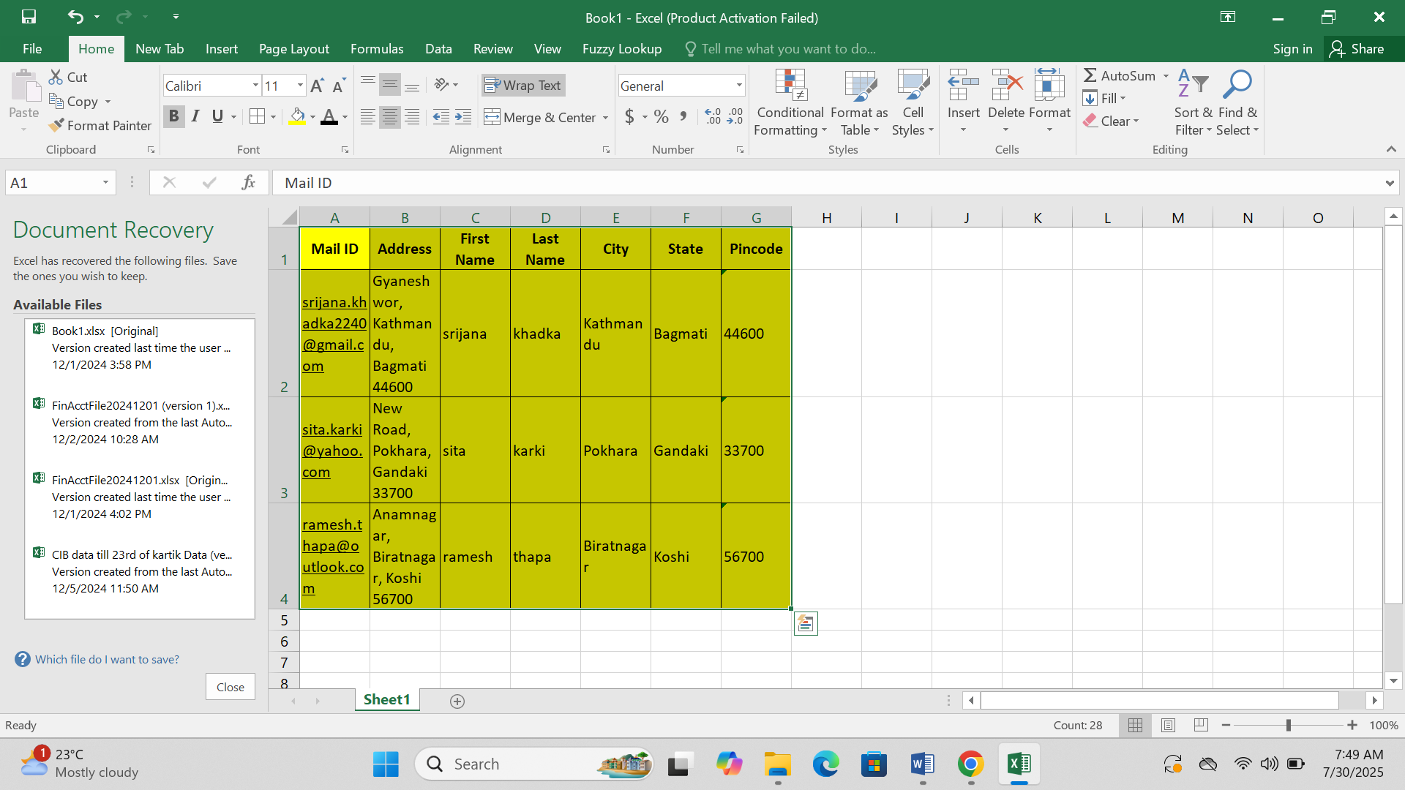

3. What is Freeze Panes and why do we use it? Give examples.

* Freeze Panes locks specific rows or columns so that they stay visible while you scroll through the worksheet. It is used to keep headers or important information visible while scrolling.

Example:

If Row 1 contains column headings, freezing it keeps headings visible while scrolling down.

4. What are the different features available within the Freeze Panes command?

The different features available within the Freeze Panes command are:-

Freeze Panes – Freezes rows above and columns to the left of the selected cell

Freeze Top Row – Freezes the top row only

Freeze First Column – Freezes the first column only

These options are found under the View tab → Freeze Panes

5. Explain what the different sheet options present in Excel are and what they do?

In Worksheet the standard grid of rows and columns where you can store, calculate, and analyze data.

In chart Sheet a sheet dedicated to a chart, separate from the main worksheets. Useful for visual analysis.

And In Macro Sheet it is Used in older versions for storing script/code.